INVENTION DISCLOSURE

This Invention Disclosure form requests inventors to specify all details of the invention and its commercial value. This form will then form the basis of a more detailed subsequent individual discussion.

Only inventions* with a good commercial potential, reasonable market size and clear competitive advantage are filed. Inventors should look for potential licensees of their invention during every phase of the technical development and the patenting procedure.

Title of the Invention
A short descriptive title.

Names and affiliations of inventors

Personal details | Inventor 1 | Inventor 2 | Inventor 3
First Name(s)
Last Name
Gender
Nationality
E-mail
Telephone
AMI Role
Gender
Private Address
Street and Number
Postcode and City
Country
Invention Share
Percent %
Contact Person
- Inventors should include only those persons that have contributed to the concepts included in the invention. Please note that being present during a meeting, providing research support, or performing or setting up experiments, does not indicate a contribution to the conception of the invention.
- Your private address will be needed by the patent office.
- Contribution of the inventor to the invention. Must add to 100% for all inventors together.

Keywords
Keywords that will help define publication and patent searches.

Description of the Problem
Explain in detail what problem(s) does your invention solve?

Description of Invention
- Describe your invention
- What parts (steps, if a method) make up the invention?
- Which parts are new to this invention, which are old (conventional, used in the expected way)?
- Which part are essential to the invention which parts could be left out?

Feature (step/part) | Description | Comments (new/old, essential/non-essential)
1
2
3
4
5
6

Key feature of your invention and its effect
Which feature (listed above) is the key feature of your invention? Which effect does it have?

Prior Art
What is the closest device/product/method you are aware of to your invention? Please provide 3 references.
Reference | Describe the similarities | Describe the differences

Project related to the invention
Is the invention made in a project with an external financial contribution (industry, FNS incl. NCCR, foundation, EU)?

Confidentiality
Has the invention been disclosed to anybody? Are there plans to publish or otherwise disclose the invention? If yes, specify the realistic time of publication, as a patent application should in any case precede a publication.

Limitations
When will the invention not work?
- Are there any critical ranges of size, weight, pressure, etc. for any of the parts of your invention?
- Must some parts be made of specific substances?

Commercialization
(AMI does not file patent applications for all Invention Disclosures it receives due to the high costs of the first and subsequent filings. If possible, it is desirable to have an interested potential licensee before committing to patent filing. Only inventions with a good commercial potential, reasonable market size and clear competitive advantage are filed. Inventors can and should look for potential licensees of their invention during every phase of the technical development and the patenting procedures.)

Companies (List companies or organizations, which could be interested in using this invention. Please indicate if you already had contact with a company.)

Spin-off (Do you have plans to spin off a company based on your invention?)

Marketing (Would you be willing to participate in the marketing of this invention by explaining it to potential commercial partners?)

Next steps toward commercialization
What are the next steps you intend to pursue for the commercialization (e.g. contacting companies or potential customers that might be interested in your product or service, seeking external funding for commercialization (Innosuisse, Bridge), discussion with potential industrial implementation partners who may wish to license the technology)?
Tasks | Description | Responsible person | Deadline (Date)
Task 1 for example Innosuisse application with/without industrial partner
IMPORTANT ! You can ask Innosuisse to cover patent costs
Task 2 for example BRIDGE application

You may not get a patent on an invention which was already patented, or described in a printed publication, presented orally in the public, or in public use or on sale or offer for sale by anyone before you apply for a patent.

Practical information regarding the filing process:
Patents have a set lifetime, the lifetime of a priority application is 12 months, after which a decision regarding abandoning the patent application or extending it to international (PCT) or going directly to national phase has to be taken. Patents applications are valid only in the selected (and paid for) countries or regions.

The cost for a priority application is ca. CHF 10’000, and again ca. 10’000 for an international (PCT) patent application, costs of national applications depends on the countries and their number. For this reason, the decision to extend patent protection after the first 12 months depends on the efforts taken by the inventors for commercialization in the first year and on the chances of bringing the technology to the market.

For technical and costs reason it is strongly suggested to keep patent applications within max. 15 claims.

If the intention is to file only in the EU and in the US, it makes sense to skip the international (PCT) phase and file directly in the EU countries of interest and the US from a priority European patent application.

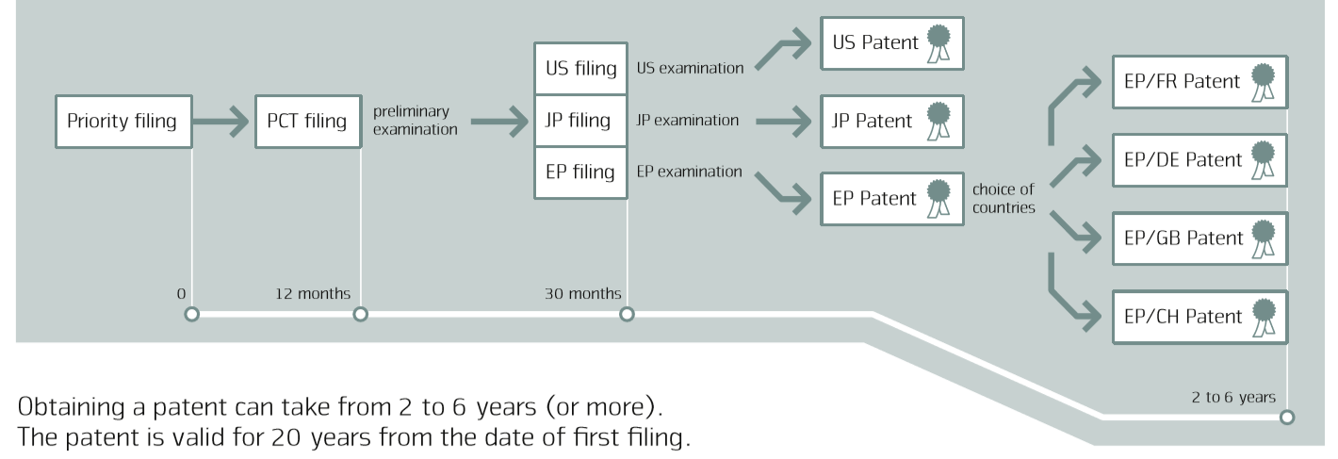
Image: ://tto.epfl.ch
Image: ://tto.epfl.ch

Signatures
Please print this document in PDF, sign it electronically and send it to the AMI Technology Transfer Manager.

Date:
First, Last Name and Signature:

Date:
First, Last Name and Signature:

Date:
First, Last Name and Signature:

? Invention: New product, process or apparatus or any new use thereof. To be patentable, an invention must be novel, involve an inventive step (i.e. not be obvious to those having ordinary skill in the particular art of the invention) and be susceptible of industrial application (European Patent Office, https://www.epo.org/service-support/glossary.html)

